Jawaban Test Sicepat

1. Jawaban soal pembuatan query

* Buat query jika mencari employee name dan status employee?

*SELECT emp_name, emp_status FROM tbl_employee*

Screemshoot:

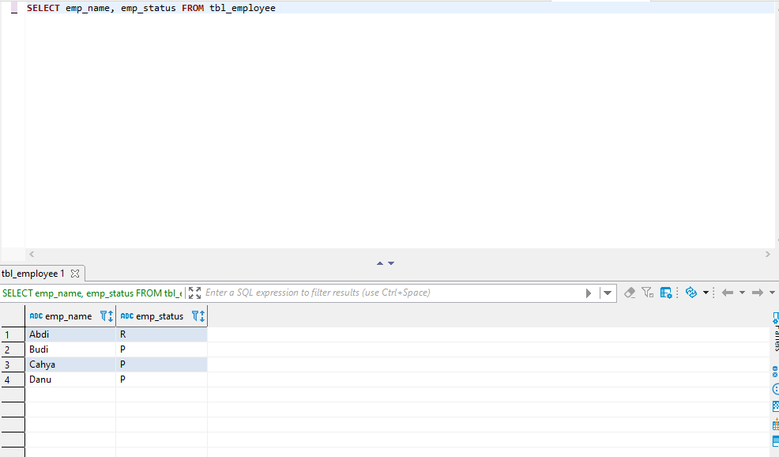

* Buat query untuk menampilkan nama employee yang statusnya resign berserta gaji yang diperoleh?

*SELECT emp.emp_name, emp.emp_status, inc.emp_income*

*FROM tbl_employee emp*

*INNER JOIN tbl_income inc ON emp.emp_code=inc.emp_code*

*WHERE emp.emp_status = 'R'*

Screenshoot:

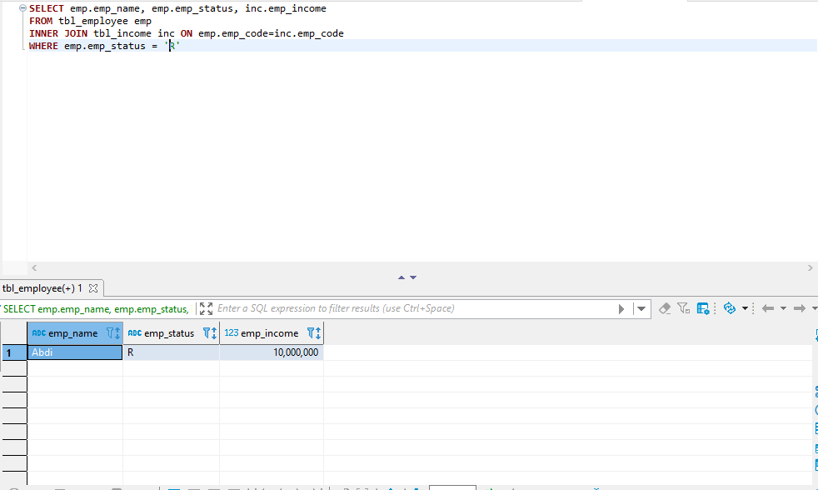

* Buat query untuk menampilkan emp_code, nama, status, income dan sorting berdasarkan income paling besar?

*SELECT emp.emp_name, emp.emp_name, emp.emp_status, inc.emp_income*

*FROM tbl_employee emp*

*INNER JOIN tbl_income inc ON emp.emp_code=inc.emp_code*

*order by inc.emp_income desc*

Screenshoot:

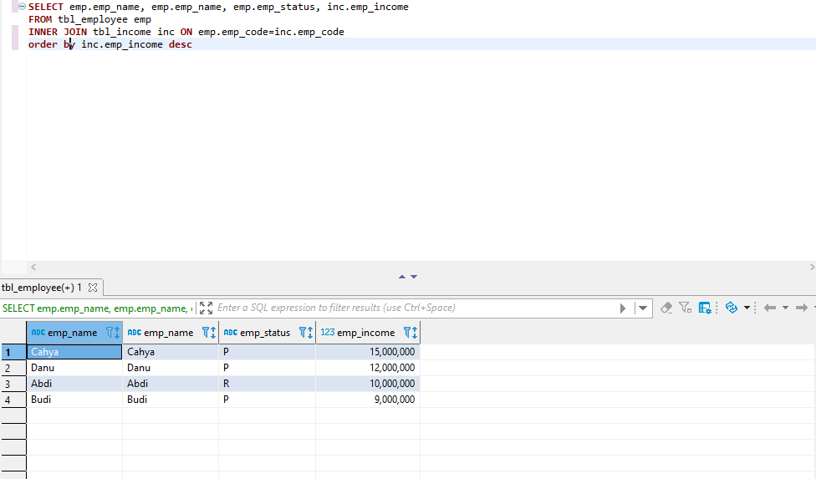

1. Buatkan script automation (Bahasa Pemograman Apa Saja) untuk alamat website https://www.saucedemo.com/ beberapa testcase berikut.

* Link Github: <https://github.com/nurhadisantoso48/Testsicepat>
* Link Video Running katalon:

[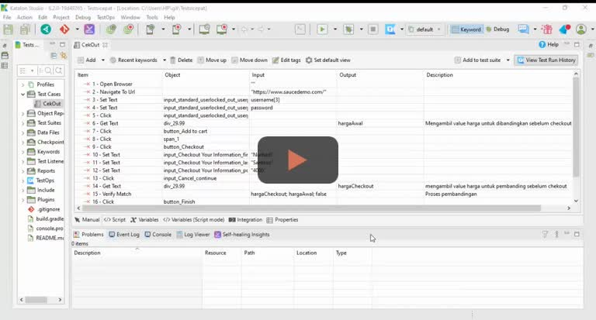](https://nurhadisantoso48qa.hippovideo.io/video/play/PyQ3t2gLD6E1EoMRJnciZi0Fe0zy_A-8zBJjv0pqQzk?utm_source=hv-campaigns&hreferer=private&hvre=false&_=1670213472473&)

[Watch Video](https://nurhadisantoso48qa.hippovideo.io/video/play/PyQ3t2gLD6E1EoMRJnciZi0Fe0zy_A-8zBJjv0pqQzk?utm_source=hv-campaigns&hreferer=private&hvre=false&_=1670213472473&)

* Link video Running di Chrome:

[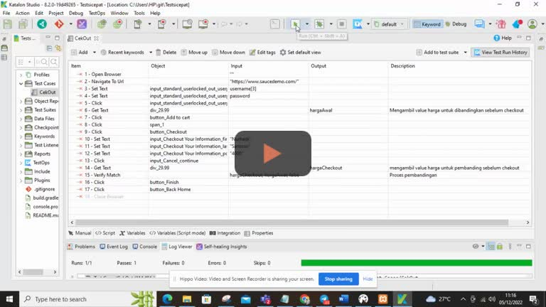](https://nurhadisantoso48qa.hippovideo.io/video/play/jxt_iiEpOKZVvgRmv4MjP0EVn6mQHIoSmgXchnp7inY?utm_source=hv-campaigns&hreferer=private&hvre=false&_=1670213937434&)

[Watch Video](https://nurhadisantoso48qa.hippovideo.io/video/play/jxt_iiEpOKZVvgRmv4MjP0EVn6mQHIoSmgXchnp7inY?utm_source=hv-campaigns&hreferer=private&hvre=false&_=1670213937434&)